TRAINING AND PLACEMENT CELL
ACADEMIC YEAR 2024-2025
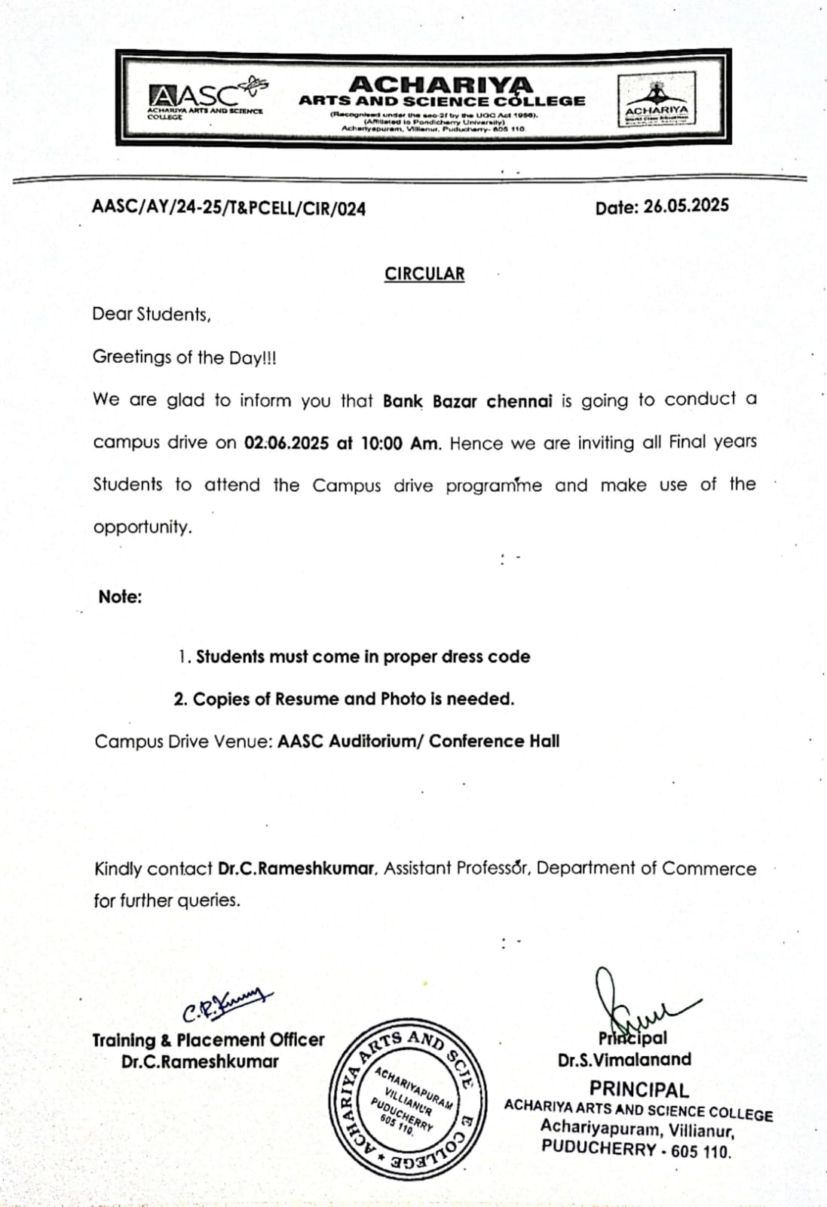
BANK BAZZAR PLACEMENT DRIVE ON 02.06.2025

